Problem 1

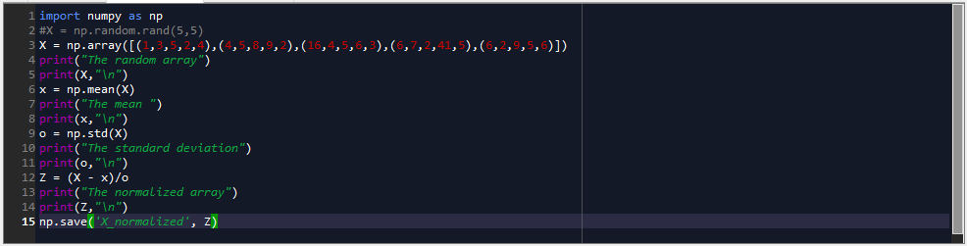

Output

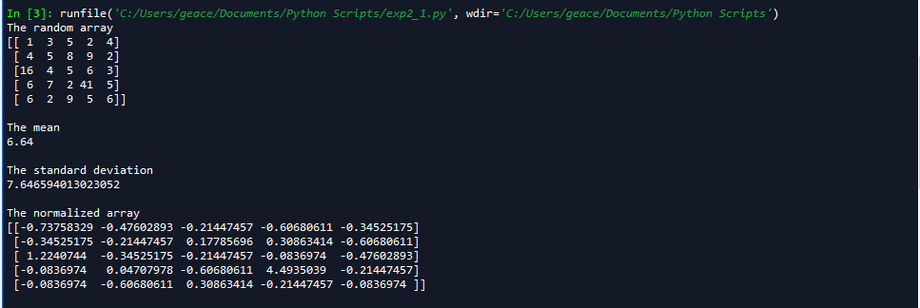

Reloading the array

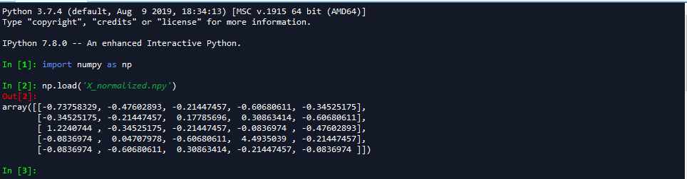

Problem 2

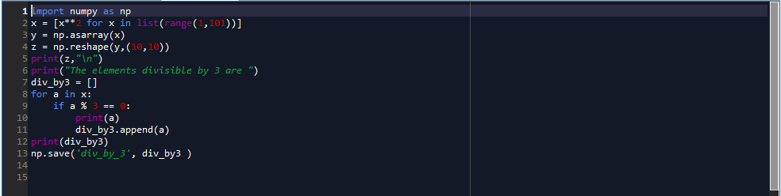

Output

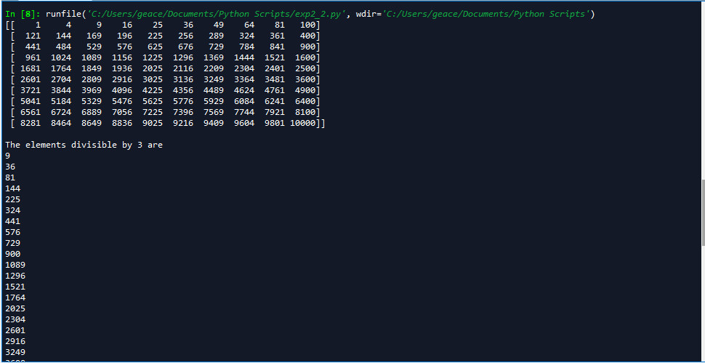

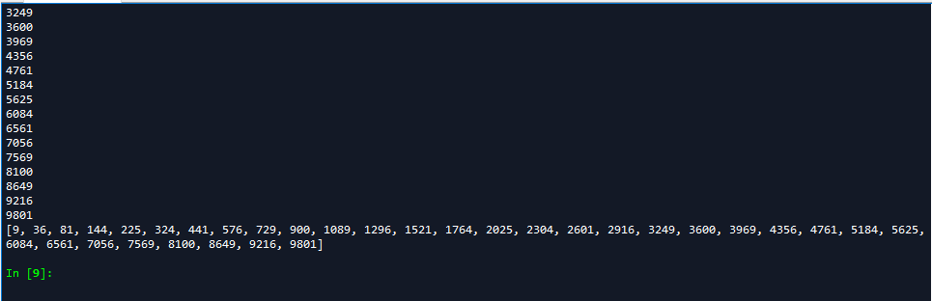

Reloading the array

